Programming Assignment #5

(for Ch 6)

Problem Description

The electric company charges according to the following rate schedule:
9 cents per kilowatt-hour (kwh) for the first 300 kwh
8 cents per kwh for the next 300 kwh (up to 600 kwh)
6 cents per kwh for the next 400 kwh (up to 1,000 kwh)
5 cents per kwh for all electricity used over 1,000 kwh.

Implement the following functions:
Get_data – Prompts the user to enter the customer number and the kwh used and send these data back to the calling module via output parameters. Do not forget to include the code for discarding extra input characters.
Calculate_charge – Takes kwh used as input parameter and returns charge as function value.
Print_results – Takes three input parameters, the customer number, the kwh used, and the charge, and displays all three values with format to 2 decimal places as shown in the sample run.

The program should print a three-column chart listing the customer number, the kilowatt-hours used, and the charge for each customer. The program should also compute and print the number of customers, the total kilowatt-hours used, and the total charges.

Sample Run

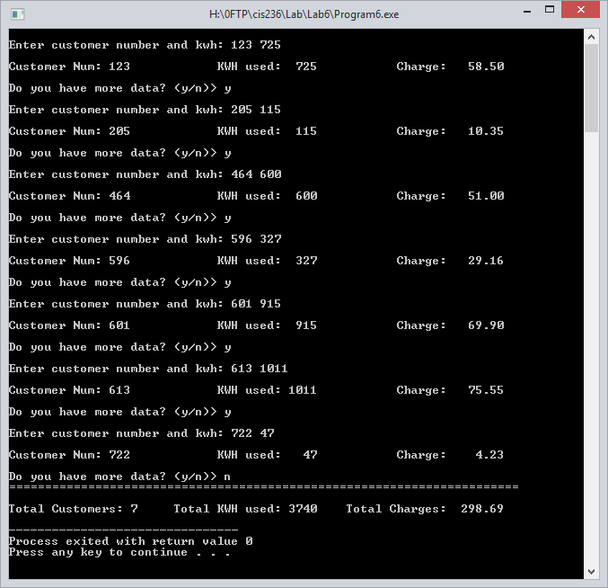

Problem Requirement
a) You must create a file and save it as Program5.c file.
b) The charges must be in 2 decimal places.
c) The program must have the necessary user-defined functions.
d) The KWH used and the total KWH used values must be right-aligned. The Charge and the Total Charges values must also right-aligned (see the sample run).
d) Your program should run correctly with the same inputs and outputs as given in the sample run.

